Jonathan Lloyd

SYSEN 5411 Fall 2025

**Lab 2 Writeup – Forward Kinematics**

**Part 1**

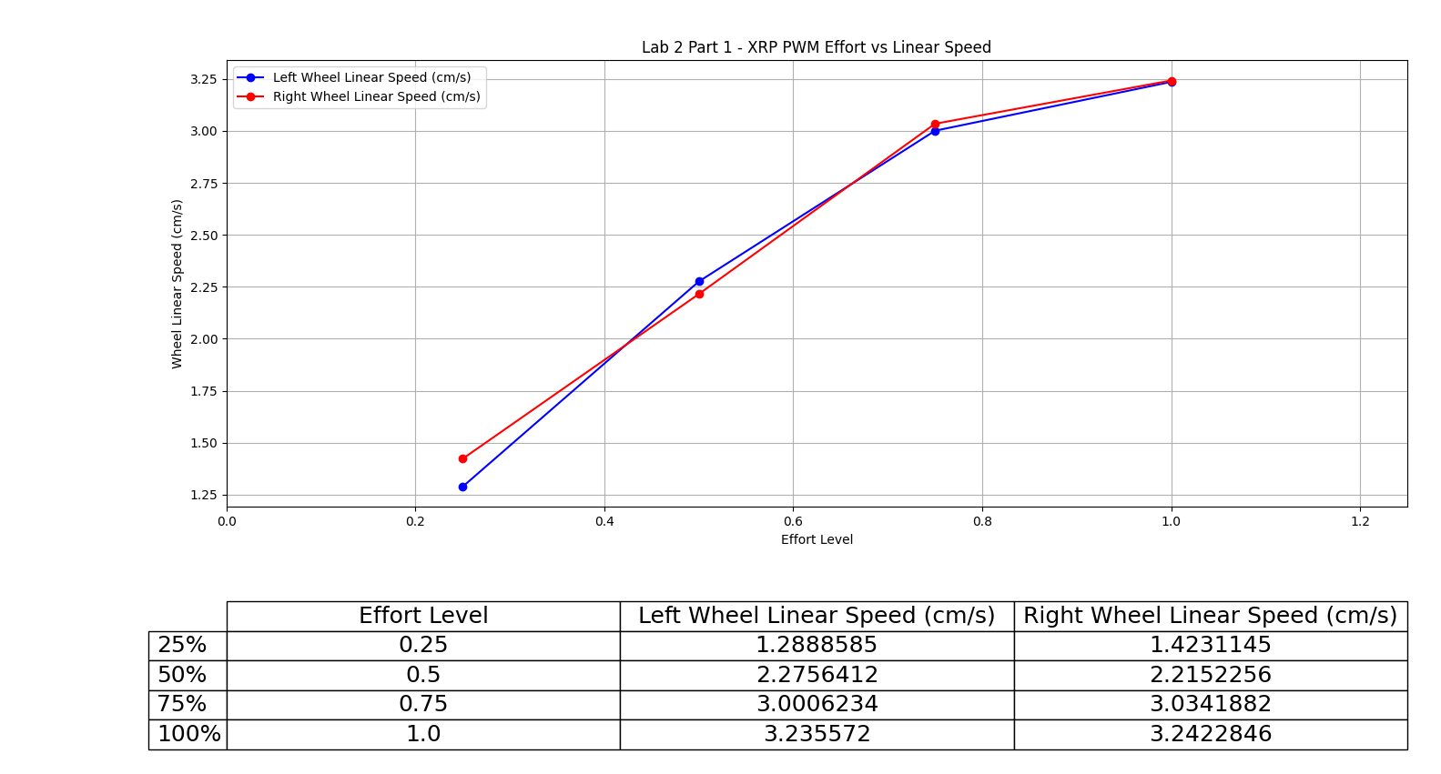

The relationship between commanded effort level and linear speed seems to be roughly linear through the 75% command. From 75% to 100%, the relationship seems to break down into nonlinearity.

**Part 2**

Video link to maneuver 1: <https://youtu.be/YuSoHposGy4>

Video link to maneuver 2: <https://youtu.be/IFM7d57Ceo0>

**Kinematic Calculations**

See code in ZIP for math – coordinate convention is +x forwards, +y left, positive theta CCW

Sequence 1: (x, y, theta) = (2.64, 4.74, -15.28)

Sequence 2: (x, y, theta) = (39.23, 36.68, 68.75)

**Measurements of Actual Final Pose**

Sequence 1: 6 cm forwards, 0 degrees angle

* (x, y, theta) = (6,0,0)

Sequence 2: 53.3 cm forwards, 55.5 degrees angle

* (x, y, theta) = (30.19, 43.93, 55.5)

**Comparison Table**

|  |  |  |  |
| --- | --- | --- | --- |
|  | Predicted | Actual | Error Vector |
| Sequence 1 | (2.64, 4.74, -15.28) | (6, 0, 0) | (-127.6%, 100%, 100%) |
| Sequence 2 | (39.23, 36.68, 68.75) | (30.19, 43.93, 55.5) | (23.05%, -19.76%, 19.28%) |

**Error Analysis and Discussion**

It was evident that the low cm/s speed commands exhibit a significant degree of nonlinearity. Comparing the robot’s reaction to set_effort() commands versus set_speed() commands, commanding the robot to 100% effort in Part 1 of this lab resulted in reported speeds of just over 3 cm/sec. In Part 2, commanding the robot to a given low speed only resulted in much lower observed speeds. One may hypothesize that there are nonlinearities in the motor/speed mapping at low speeds. It may be the case that the microcontroller is translating commanded speeds to efforts on a linear scale while the true curve breaks from linear at low speeds. This hypothesis is hard to prove or disprove from the Part 1 curve because no data points were collected below 25% commanded effort. However, observing the nonlinearity between 75% and 100%, it may not be a stretch to postulate that the true command curve takes an S shape, with nonlinearities close to 0% and 100%. Indeed, error percentages were much lower for Maneuver 2 (executed at higher speeds) compared to Maneuver 1.

Terminal output of kinematic predictor code:

